9-3
Comparing Intermolecular Forces in Three Different Gases

Description: Balloons containing helium, oxygen and carbon dioxide are submerged in liquid nitrogen. The helium remains in the gas phase, the oxygen becomes a liquid and the carbon dioxide becomes a solid.

Materials:
- Balloons
- Lightweight string
- Cylinders of O₂ and He
- Dry Ice or CO₂ cylinder
- 250 mL Erlenmeyer flask
- Recrystallizing dish
- Evaporating dish
- Scissors
- Thermal gloves
- Liquid N₂
- Gap magnet (optional)
- Projectable Camera (optional for larger classes)

Safety: Wear the thermal gloves at all times when working with the liquid nitrogen. Oxygen in any phase can be a potential hazard. Make sure that the oxygen does not approach any source of sparks or flame.

Concept:
Though mass plays an important role in determining the phase that each gas will be in at -210ºC (the temperature of liquid nitrogen), it is valid to compare the intermolecular forces that are effective in the three gases. Since each gas is nonpolar, contains no ionic bonds and no hydrogen, the only intermolecular forces to be considered are London dispersion forces. These forces are caused by the induced dipoles that are created in molecules when the electrons in neighboring molecules approach.

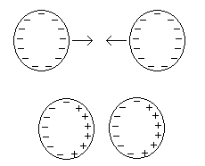

It is the attraction between induced dipoles that holds neighboring molecules in close proximity to one another. The magnitude of this attraction is dependant on the mass of the molecules in question, and the total number of electrons within each molecule. Molecules with greater mass and a higher electron count will generally have a greater magnitude of dispersion forces between them. The mass and electron count for the gases in question are shown below:

Gas | Mass (g/mol) | Electrons | Freezing Point
Helium | 4.0026 | 2 | -271ºC
Oxygen | 31.9988 | 16 | -218ºC
Carbon Dioxide | 44.0095 | 22 | -78ºC

When we submerge these gases in liquid nitrogen (-210ºC), we are slowing down molecular motion. At slower speeds, molecules have more time to interact with one another. Intermolecular forces play a larger role in determining the phase of a substance at lower temperatures, since these forces are enhanced by the slower speeds of the molecules. We observe these effects when the phase of each of the substances listed above is examined at a low temperature. The helium remains as a gas, the oxygen will condense into liquid form and the carbon dioxide with become a solid. Though these phase differences are generally attributed to the differences in molecular mass, this situation provides for a good discussion of London dispersion forces.

Procedure:
Before Class:
Fill two 11” balloons ½ - ¾ of the way with oxygen (one for backup), one balloon with helium and stretch the last balloon over a 250mL Erlenmeyer that contains a few pieces of dry ice. Fill a dewar with liquid nitrogen.

During Class:
Fill the recrystallizing dish about 1/3 full of liquid nitrogen. The balloons can be submerged in any order.

Helium: Squeeze the balloon so that it is narrower than the diameter of the dish and push it into the liquid nitrogen. The helium in the balloon will never completely condense, but the density change will be sufficient to prevent the balloon from floating. Leave the cold balloon on the countertop for about one minute, and the balloon will eventually rise as the temperature of the helium increases.

Oxygen: Squeeze the balloon so that it is narrower than the diameter of the dish and push it into the liquid nitrogen. The oxygen will condense more quickly and completely than the helium. Hold the balloon by the tied end while this is happening. When the balloon is completely deflated, bring the evaporating dish near and cut off the top portion of the balloon (see diagram below). Quickly pour the contents of the balloon into the evaporating dish to observe the blue color of the liquid oxygen. If desired (this can be tied in to a later discussion), pour the liquid oxygen from the evaporating dish into the gap magnet to show the paramagnetism.

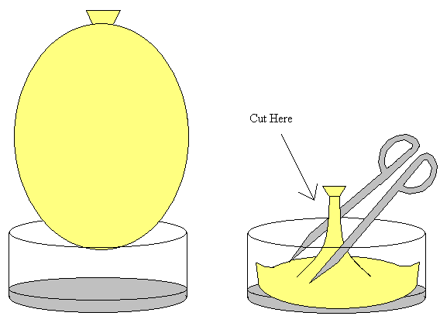

Carbon Dioxide: Squeeze the balloon so that it is narrower than the diameter of the dish and push it into the liquid nitrogen. In a few seconds, the contents of the balloon will be completely condensed. The balloon can be cut open in the manner described above and the solid carbon dioxide can be shaken out.

