7-15
Relating Color to Absorbance Spectra

Description: Six, colored solutions are shown to the students while a color wheel and a visible light spectrum is projected onto the wall. The students are shown transparencies of six different absorbance spectra, and are asked to aid in predicting which spectrum corresponds to which solution.

Materials:
- Two overhead projectors
- Color wheel transparency
- Visible light spectrum transparency
- Absorbance spectrum transparencies for the 6 solutions
- Samples of the 6 solutions
- Key for distinguishing spectra

Concept: If a solution appears to be red, then it is reflecting red light and absorbing the color of light that lies across from red on the color wheel.
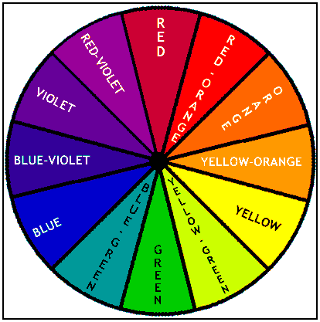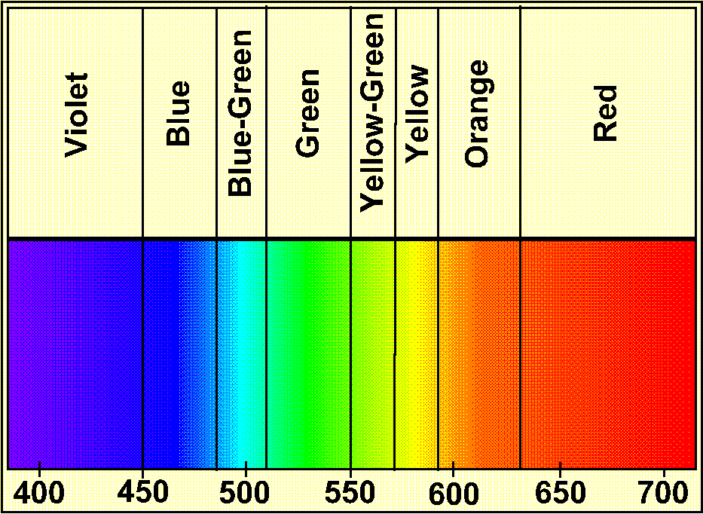
Looking at the color wheel above, we can see that green lies directly across from red. According to the visible light spectrum above, we see that green light lies between about 510 and 550nm. Therefore, we should expect a solution that is pure red in color to have an absorbance spectrum with a peak somewhere in this region. The spectrum for a CoCl₂ solution, which is red in color, contains one major peak that is centered around 510nm.

Procedure: Present the color wheel and the visible light spectrum to the students on one projector. Both will not fit on the same projector, so these must be shown one at a time. The other projector will be used for displaying the absorbance spectra. Present the solutions one at a time to the students. The students may need help interpreting the information given to them at first, but after practicing with one or two solutions, the students should be able to predict which solution corresponds to a given absorbance spectrum. Present a new spectrum and give the students some time to think. If someone wants to make a prediction, have them explain their reasoning to the class.

