16-6
A Simple Buffer Demonstration

Source: Borrowed from the Purdue lecture demonstration site:
http://chemed.chem.purdue.edu/demos/main_pages/17.4.html

Description:
Four beakers (or crystallizing dishes) are filled to the same level: two contain water while two contain acetate buffer. Indicators are added to each. Acid and base are added to the water-filled beakers and to the buffer-filled beakers. No color change can be observed in the buffer-filled beakers.

Materials:
- Four beakers or crystallizing dishes (for overhead projector)
- Acetate buffer:
  - Fill 1000 mL volumetric with about 600 mL dH₂O
  - Add 172 mL glacial acetic acid
  - Add 246 g sodium acetate
  - Dilute to 1 L
- Four stirring rods
- 1 M NaOH
- 1 M HCl
- Beral pipets

Safety: Gloves and goggles should be worn whenever working with acids or bases.

Procedure:
Set up the beakers as shown:
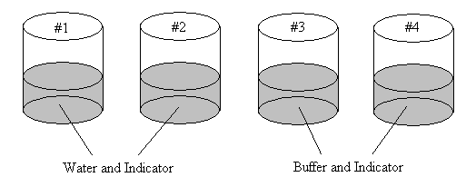
Add the 1 M HCl to beakers 1 and 3 using a pipet and stir with the stir rod provided. Add the 1 M NaOH to beakers 2 and 4 using a pipet and stir with the stir rod provided. The solutions in 3 and 4 should not change color, while the solutions in 1 and 2 should. Pour a little more HCl and NaOH from the bottle into beakers 3 and 4 respectively. These should not change the color until the buffer capacity has been reached.

Clean-Up:
The waste is safe to rinse down the drain with water.

Background:
The addition of strong acid or base to the buffer system will not affect the pH by a very large degree, since acid addition results in the production of a weaker acid and water, and base addition results in the production of a weaker base and water.

CH₃COOH + OH⁻ → CH₃COO⁻ + H₂O (Addition of Base)

CH₃COO⁻ + H₃O⁺ → CH₃COOH + H₂O (Addition of Acid)

