12-24
Homemade Slime

Description:
Typically done as a hands-on activity for children, “Homemade Slime” can be modified for use as a demonstration of polymerization. A Borax solution is mixed with a solution of white glue. The result is a rubbery substance with very unique properties.

Materials:
- 5% Borax solution
- 50/50 solution of white glue and water
- Plastic bag or 250mL beaker with stir rod
- Food coloring (optional)

Concept:
White glue contains polyvinyl alcohol. When mixed with water, this polyvinyl alcohol dissolves. Borax acts as a crosslinking agent when added to this glue solution, creating a new, rubbery polymer.

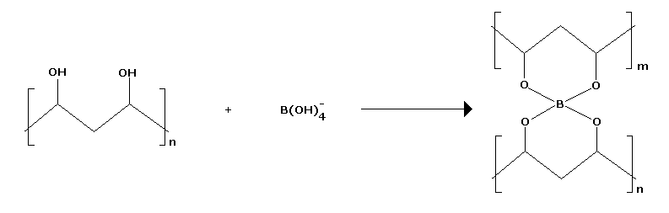
Procedure:
Prepare a solution that is 5% (by mass) borax in water. Each person making slime will need about 100mL, so plan the final volume accordingly. Make an equal volume of a solution that contains 50% white glue and 50% water. The glue solution will need to be stirred thoroughly. These solutions can be prepared ahead of time, or making the solutions can be part of the activity or demonstration. If the latter is chosen, it is best to add any food coloring to the water that is to be mixed with the glue. To make the crosslinked polymer, mix 100mL of the borax solution with 100mL of the glue solution in a 250mL beaker or knead the mixture in a sealable plastic bag.

Safety:
Remind any children that there are chemicals being used here, and this is not safe to put in their mouth.

Clean Up:
Keep the slime off of furniture and carpets. The slime can be stored for long period in a refrigerator, but will dry out and/or grow mold if left sitting in room temperature too long.

