12-23
Rayon from Dryer Lint

Source: Knopp M. A. J. Chem. Educ. 1997, 74, 401

Description:
Cotton or dryer lint that has been dissolved in aqueous [Cu(NH₃)₄(OH)₂] is injected from a medicine dropper into 3M H₂SO₄. The result is a thread of rayon.

Materials:
- Copper (II) carbonate powder
- Concentrated ammonium hydroxide
- Cotton ball or dryer lint
- 3M Sulfuric acid
- 190 x 100mm crystallizing dish
- Medicine dropper
- Stirring rod
- 8 dram vial
- Two 100mL beakers
- Stir plate and stir bar

Concept:
Edward Schweizer was the first to report that a saturated solution of copper (II) carbonate in concentrated ammonium hydroxide would dissolve cellulose. The cellulose is held in solution by complexation of the Cu²⁺ ions with the deprotonated hydroxyl groups of the cellulose chain.
nCu²⁺ + (C₆H₁₀O₅)_{n} + 2nOH⁻ → (CuC₆H₈O₅)_{n} + 2nH₂O

The cellulose polymer is regenerated as extruded fibers when the complex is reprotonated below the surface of the sulfuric acid. The polymer prepared is referred to as cuprammonium rayon, and is an example of regenerated cellulose. Regenerated cellulose is usually less crystalline than natural cellulose. The chemical structure of the product can be represented by the following formula:
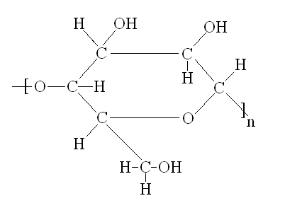

Procedure:
Before Class:
Prepare the [Cu(NH₃)₄(OH)₂] solution by dissolving 2.27 grams of basic copper (II) carbonate powder in 50mL of concentrated ammonium hydroxide in a 100mL beaker. This should be done in a hood, as the fumes from the ammonium hydroxide are quite irritating. This mixture should be stirred for about 5 minutes before decanting the liquid portion into a second 100mL beaker. Dryer lint (0.7 grams) or a full cotton ball is added to the liquid in small portions while stirring with a glass rod until a viscous liquid is created. The liquid should then be stored in an 8 dram vial for use in the lecture.

During Class:
Pour 200mL of 3M sulfuric acid into the crystallizing dish and place this on an overhead projector. Draw the viscous cellulose solution into the medicine dropper and submerge the tip of the dropper below the surface of the sulfuric acid. Squeeze a small amount of the material into the acid, and hold this to the side of the crystallizing dish with the stirring rod. Squeeze the remaining material from the medicine dropper using even pressure, while pulling the dropper across the length of the crystallizing dish. The result will be a blue thread of rayon. The color of the rayon will eventually disappear as the copper ions diffuse into solution.

Safety:
The cellulose solution contains concentrated ammonium hydroxide, and should be handled with care. The vapors may become irritating. Wear gloves and goggles while performing any demonstration that uses strong acids and bases.

Clean Up:
Retain all solutions and prepared rayon for proper disposal by the demonstration technician.

