12-18
The Sn2 Reaction: A Model of the Sn2 Reaction Mechanism

Description:
A model has been constructed to demonstrate the Sn2 reaction mechanism. The model shows the initial tetrahedral arrangement around the central atom, the trigonal bipyramidal transition state when both nucleophiles are attached and the resulting inversion in configuration around the central atom when the new nucleophile is attached.

Materials:
- The Sn2 Model

Procedure:
See the diagram below showing the transition state arrangement:

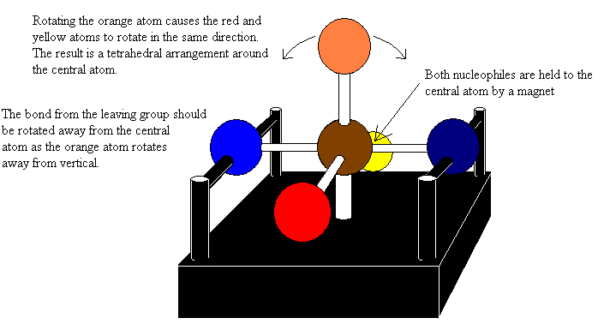
Start with the model showing a tetrahedral arrangement with one nucleophile attached. Rotate the second nucleophile towards the central atoms as you rotate the orange atom towards the vertical position. This will result in the transition state shown above. Rotate the orange atom away from its initial orientation as you rotate the leaving group away from the central atom. Note to the students the new arrangement of the red, orange and yellow atoms about the bond to the nucleophile. The arrangement will have changed from a clockwise progression of red to yellow to a counterclockwise progression or vice versa

