12-13
A Simple and Colorful Extraction Demonstration

Description: A blue, water-soluble indicator is added to a separatory funnel containing a layer of H₂O and a layer of CHCl₃. Acid is added to the blue aqueous layer, and the color changes from blue to red. After shaking, some of the red color (the protonated, organic soluble version of the blue indicator) moves into the bottom layer. After thorough mixing, the red exists solely in the organic layer. The extraction can then be done in reverse by addition of a base.

Concept: The protonation of a water soluble indicator makes a neutral compound that is soluble only in organics.

Materials:
- 1000mL Separatory funnel (Teflon stopcock and ground glass stopper)
- 1M HCl
- 1M NaOH
- 2 Beral pipets
- Stirring rod
- 2,6-dichloroindophenol solution (prepared by demo technician)
  - 25mg combined with 50mL H₂O and 1.0mL 1M NaOH.
- 500mL deionized water
- 250mL chloroform
- Large beaker for waste

Safety:
Chloroform is a suspected carcinogen. Wear gloves and exercise caution when performing the demonstration. Remember to vent gas build-up frequently.

Procedure:
(see the accompanying diagram on the next page)
Step 1— Pour the H₂O and CHCl₃ into the separatory funnel. Two layers are now visible. The more dense, CHCl₃ layer will be on the bottom.

Step 2—Add the indicator solution. The blue color will only appear in the aqueous layer, even after mixing.

Step 3—Carefully add one pipet full of 1M HCl to the top, aqueous layer. Stir only the top layer using the stirring rod if necessary. The top layer should now be red in color. Some of the color may seep into to lower layer at this point.

Step 4—Attach a stopper to the separatory funnel and invert once (be sure to release any built-up pressure caused by this mixing). The red color will be present in both layers.

Step 5—Attach the lid again, if necessary, and thoroughly mix the contents of the separatory funnel. The red color should now appear exclusively in the lower, CHCl₃ layer.

Step 6—Add one pipet full of 1M NaOH to the separatory funnel. Another thorough mixing will cause the blue color to reappear exclusively in the aqueous layer. Remember to vent gases during the mixing process.

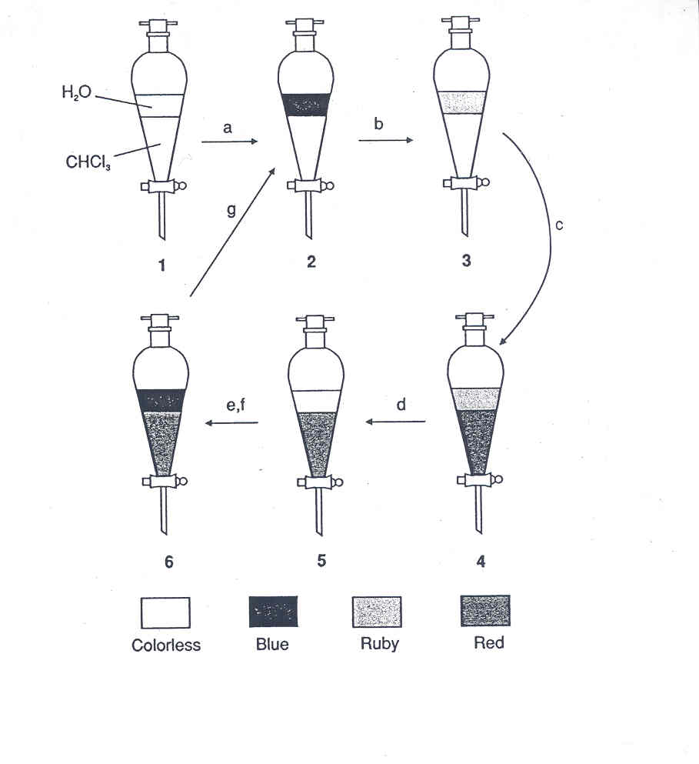

OH⁻
A⁻ HA
blue, water soluble H⁺ red, organic soluble

Clean-Up:
The waste should be poured into the beaker provided. The lecture demonstrator will dispose of any waste left behind.

