11-2
Critical Temperature

Description: A pressure chamber containing liquid sulfur hexafluoride, SF₆, is warmed to the critical temperature of the SF₆. Light is projected through a window in the chamber so that the disappearance of the line of separation between liquid and gas can be seen on a screen when the SF₆ reaches its critical temperature.

Concept: There is a temperature at which the liquid phase of a substance can no longer exist regardless of the pressure. This temperature is called the critical temperature. See notes below for further explanation.

Materials:
- Pressure Chamber for Critical Temperature containing liquid SF₆
- Steam generator made from the following:
- 500-mL round bottomed flask wrapped in tape
- Heating mantel to fit round bottomed flask
- One-holed stopper to fit round bottomed flask
- “L” shaped glass tubing in stopper
- Tygon or rubber tubing (6 mm diameter, 0.5 m long) attached to the “L” shaped glass tubing
- Another piece of tygon or rubber tubing (6 mm diameter, 0.5 m long)
- 1 400-mL beaker
- Digital thermometer for overhead projector
- Glycerine
- Lamp housing with lamp and aspherical condenser
- Lens (f = +100 mm)
- Lens to re-invert image
- Transformer 6V/30W
- Small optical bench with base
- LH multiclamps
- Overhead projector
- Pipet bulb

Procedure:
Set the equipment up using the following instructions and the diagram below:

- The base of the apparatus should be about 10 feet from the screen.
- The Lens should be at about 40 cm, the Pressure Chamber should be at about 29 cm, and the Lamp should be about 12 cm on the optical bench. Adjustments will probably need to be made to ensure the clearest image is projected. A second lens may be used after the first lens to re-invert the image so that it is not up-side down.
- Check the heating channel of the pressure chamber for any obstructions by blowing air gently through the channel with the pipet bulb.
- To improve the heat contact between the temperature probe and the chamber, put a little glycerine in the hole on top of the chamber before inserting the temperature probe (see diagram in notes to identify this hole).
- Connect the outlet tubing to the outlet of the Pressure Chamber. Put the outlet tubing in the 400-mL beaker.
- To turn the light on, connect the two banana clips into the two middle holes in the transformer (this will give the lamp 6 V).
- Adjust the projection apparatus so that the assembly is horizontal and a sharp image of the liquid level is projected.
- Fill the 500-mL round bottomed flask about half to two-thirds full with water. The heating mantle may be pre-warmed so that the water is closer to boiling before lecture.
- When heating with steam, make sure that the end of the tubing does not become immersed in condensed water; otherwise suction will cause a backflow of the cold condensed water when the apparatus cools down.
- When ready to heat the chamber, connect the tubing from the steam generator to the inlet of the pressure chamber. It is best to do this when the water is almost boiling, before steam is coming through the tubing.
- While heating the chamber, move through the temperature range above about 40°C as slowly as possible, so that the disappearance of the phase boundary can be clearly observed. Use gloves to remove the heating mantle from the water bath to slow the heating.
- Turn the lamp off when the demonstration is over by disconnecting the lamp housing from the transformer. The lamp housing will be hot!

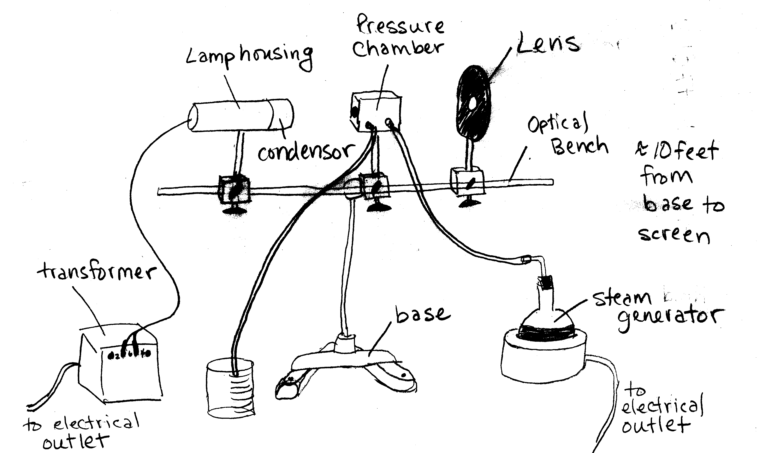

Safety:
- Only heat the pressure chamber with steam or a circulated water flow without excessive pressure (never use a flame or hotplate!)
- Do not touch the hot pressure chamber; danger of burns.
- Capture the outflowing heating water or steam safely.
- Check that all tubing is seated securely.
- Do not loosen the screw plug of the filling opening for the liquefied gas, as the chamber is under pressure (see diagram in notes for location of this screw).
- As far as possible, do not heat the chamber above 90°C, so as to ensure the longest possible service life of the gas.
- Do not heat the chamber above 100°C.
- Maximum voltage for the lamp is 6V, 30W.
- Do not cover the venting holes at the rear of the lamp housing.
- Even with the venting holes open, the lamp housing will become very hot!
- The heating mantle, steam bath, tubing, and pressure chamber will also become very hot!

Clean-up:
Carefully disconnect the tubing from the steam bath from the pressure chamber. Disconnect the lamp housing from the transformer. This makes it easier to transport the apparatus. The equipment on the optical bench can stay on the optical bench, but care should be taken when moving it all.

Notes:
The pressure chamber is about half full of a liquefied gas, sulfur hexafluoride, SF₆. The critical temperature of SF₆ is 45.5°C. Critical pressure is 37.6 bar.
From manufacturer’s notes:
“As the temperature increases, condensate begins to form and run down the glass panes; a further temperature increase causes the water [we think they should have said sulfur hexafluoride?] to boil, i.e. vapor emerges from the volume. The liquid, which is no longer homogenous due to the gas bubbles, diffuses the incident light. As a result, the projected image becomes darker.
When the critical temperature is reached, the liquid boils vigorously. The phase boundary between the liquid and the gas becomes unstable, and the image becomes almost completely dark. Finally, the phase boundary disappears completely. The image becomes lighter again, as the chamber once again contains a homogenous phase. When the temperature is increased further, we only observe formation of a condensation film on the flat glass panes.”

- 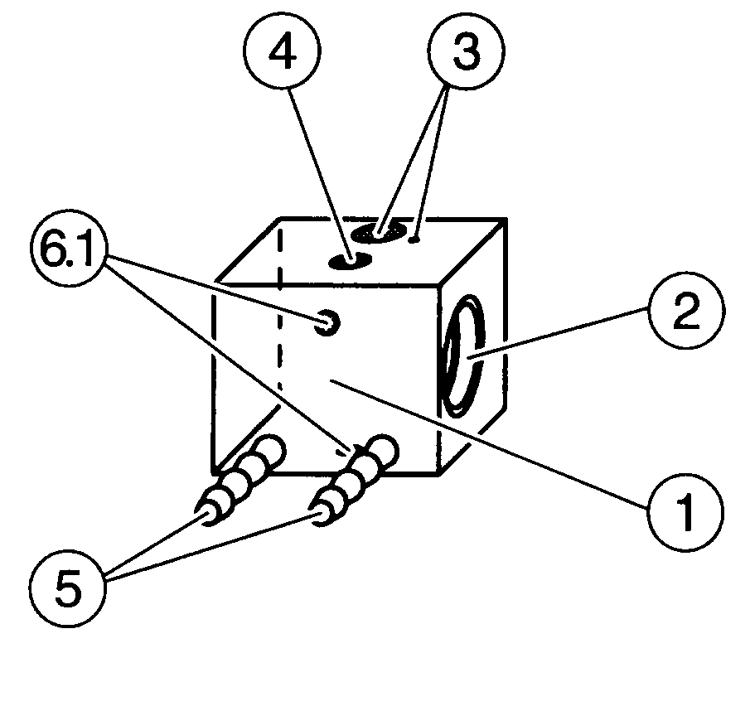Steel pressure chamber filled with liquefied gas, SF₆, with heating channel integrated in steel casing.
- Pressure-resistant view windows on both sides.
- Holes for thermometer and temperature sensor.
- Screw plug for liquefied-gas filling opening (do not open!).
- Heating channel inlet and outlet as hose fitting (8 mm diameter).
6.1 Screw holes for stand rod.

