10-15
Density of CO₂
(The Bubble Machine and Candle Staircase )

Description: For Version 1, a faucet-like contraption drips bubbles filled with CO₂ fog. For Version 2, CO₂ gas is poured down a Plexiglas staircase. Candles on the individual stairs are extinguished on at a time.

Concept: It is a common misconception that gases are without mass, and that all gases will rise when released from a container. This demonstration shows that CO₂ will fall to the ground, as it is more dense than the air surrounding it.

Materials:
Version 1:
- Bubble Machine (see diagram below)
- Dry Ice
- Water
- Bubble Solution
- 250mL beaker
- Paper towels (to dry soapy puddle)

Version 2:
- Candle staircase
- 5 small candles
- Matches
- 250mL beaker
- Water source
- Dry ice

Version 1:
Procedure: The bubble machine is disassembled (see accompanying diagram on the next page) and roughly half a pound of dry ice is added to the empty tube. Water is added to the tube until a thick fog begins to pour from the top. The machine is then reassembled. Bubble solution is put into the bottom of 250mL beaker. Once fog begins to pour from the machine, the end of the pipe should be submerged in the bubble solution. Bubbles will form when the beaker is pulled away. This may take several dips to achieve.

Clean-up: There will be a slippery puddle left on the floor. The bottom of the PVC pipe holding the dry ice is capped with a rubber stopper, which will occasionally pop off when the pressure becomes too great.

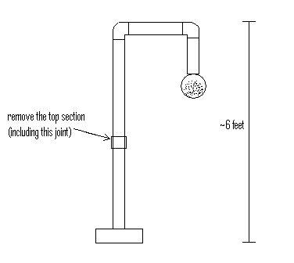
Version 2:
Procedure: Open the front, hinged panel on the staircase. Using a match, light all 5 candles as they rest on the Plexiglas stairs. Close the panel and secure the Velcro to hold the front panel in place. Put a small handful of dry ice into the 250mL beaker and add approximately the same volume of water. Pour the resulting CO₂ fog from the beaker into the opening of the staircase. The candles will become extinguished one at a time, starting with the topmost candle. See the diagram below.

