The “Collisions Cube”
Molecular Dynamics
Simulator

Instruction Booklet

Contents

About the Simulator………………………………………………………………….…3

Safety Concerns…………………………………………………………………………3

Tips for Using the Machine…………………………………………………………….3

Using the Simulator to Demonstrate the Molecular Motion
of the Various Phases…………………………………………………………………...4

Using the Simulator to Demonstrate Pressure………………………………………..5

Using the Simulator to Demonstrate Chemical Equilibrium………………………...6

Using the Simulator to Demonstrate Entropy………………………………………...7

Using the Simulator to Demonstrate Activation Energy……………………………..8

Using the Simulator to Demonstrate Orientation
between Colliding Atoms/Molecules…………………………………………………..9

Using the Simulator to Demonstrate Distillation……………………………………..10

Using the Simulator to Demonstrate Evaporation/Diffusion………………………...11

About the Simulator
The original design for the simulator was developed by John Nash and Paul Smith of Purdue University. This particular simulator is an adaptation of the original created by Matt Nance, Gary Fleener and the Machine Shop in the Chemistry Department of Indiana University Bloomington.

The machine operates on two large furnace blowers which are controlled through Variacs. Adjusting the speed of the blowers is analogous to adjusting the temperature of the system with the chamber. Ping-pong balls are used to represent atoms or molecules, and behave much like atoms or molecules are predicted to behave according kinetic molecular theory. The 2’ x 2’ x 3’ chamber can be subdivided into two separate chambers that act independently of one another. This is established through the use of various dividers that have been created for a variety of demonstration purposes. The ways in which this simulator can be used are described within this booklet, but the uses are not limited to what is contained within these pages. If you have any new ideas on how to use this simulator, please share them with Matt Nance (mjnance@indiana.edu) and he will add your ideas to this booklet for the benefit of others.

Safety Concerns
Since this machine uses squirrel cage-type furnace blowers, there is a risk associated with the moving parts. Please keep hands and any other objects (including the power cords) clear of the furnace blower openings when the machine is in use.

The lid of the machine may build up a static charge during use. Exercise caution when removing the lid.

Tips for Using the Machine
In order to operate the machine, five switches must be set to the “on” position: the switch on the power strip, the switches on each of the Variacs and the switches on the two furnace blowers. The only part that needs to be plugged in is the power strip.

The lid fits snugly over the top of the chamber and is a little difficult to put on the chamber. To replace the lid, stand behind the machine and put the front half onto the chamber. The front and back sides should be marked. Once the front section is in place, the back section can be pulled over the chamber.

The dividers should be put in when there are no ping-pong balls in the chamber. There are slots lining the inside of the chamber that will hold the dividers in place. You may need a stool when putting the dividers in.

The Variacs are marked “ON” at the point where the blowers just start to move. This position will not create much motion among the ping-pong balls, but small adjustments will yield big results. Occasionally, if the Variacs are set too high, the fuse will cut out and must be replaced. Extra fuses can be found in a vial that is stored with the cart. If you turn the Variac past the “ON” position and no motion occurs, try changing the fuse.
Using the Simulator to Demonstrate the Molecular Motion of the Various Phases

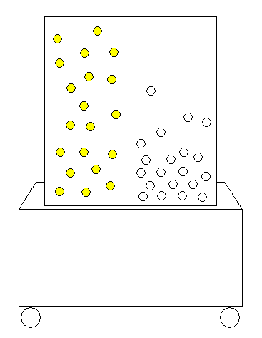
This demonstration works best when the solid divider is placed in the machine. Since the two sides become independent of one another, it is possible to show side-by-side comparisons of the different phases.
When the blowers are turned off, the ping-pong balls will take on a somewhat ordered arrangement at the bottom of the machine. If the variac is set so that the “ON” position is barely surpassed, this representation of a solid will begin to vibrate.
When the blowers are provided with a little more power, the ping-pong balls will begin to hover, representing the presence of a vapor. The students should be pointed to the equilibrium that exists between this vapor phase and the liquid phase that lies below.
When the variacs are set to 2/3rd or 3/4th of their maximum, one gross of ping pong balls will provide a good representation of the gaseous phase. It should be pointed out that not all “molecules” are moving at the same speed, but on average, as you raise the temperature (or blower power), you will be raising the kinetic energy to a degree proportional to the temperature change.
The diagram shows the machine with a divider inserted. The left side of the machine is demonstration the gaseous phase, while the right side is demonstrating the liquid phase.

Using the Simulator to Demonstrate Pressure

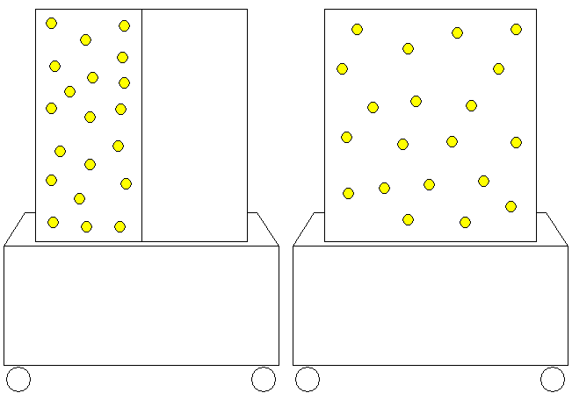
Boyle’s law can be demonstrated (PV = constant) by showing the machine in two different arrangements. One gross of ping-pong balls is put into one half of the machine with the solid divider set in place. The variac is set so that a gaseous phase is represented. This setting should be at around 80-90 volts. The frequency of collisions between the ping-pong balls and the plexiglass should be noted, as well as the density of the molecules within the single chamber.
The divider should then be removed, and the demonstration should be repeated with both variacs set to about 65-75 volts. This will provide roughly the same air pressure as was provided in the single chamber with the variac set between 80 and 90. There is a definite change in density, and this may be sufficient to demonstrate the pressure reduction. Those students who are more observant should be able to observe less frequent collisions with the walls of the chamber. This is a little hard to see, but can be audibly noted if the students are prompted to listen in both situations.

Using the Simulator to Demonstrate Chemical Equilibrium

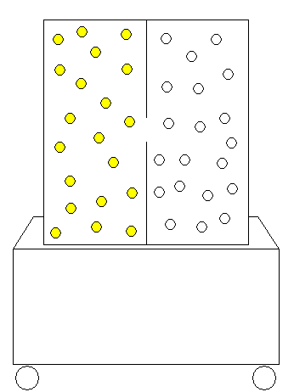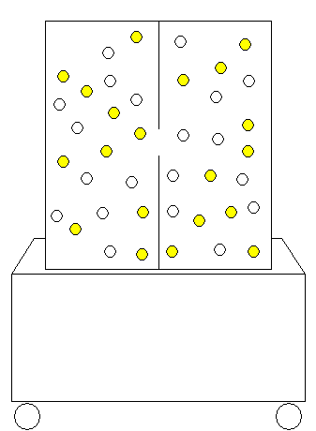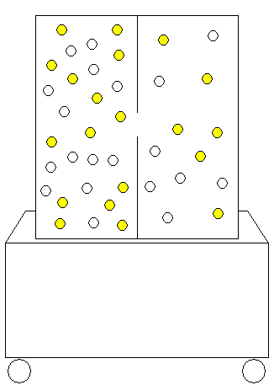

To demonstrate equilibrium, the chamber should be set up with a gross of ping-pong balls (yellow and white) on each side of the divider that contains a hole in the center. One side of the chamber is meant to represent reactants while the other is intended to represent products of the same reaction. Both variacs should be adjusted to an voltage above or around 65. If the blower powers are equal, an even distribution of each color should be established in each chamber after about 2-3 minutes. Once the distributions are about even, the reaction is said to have established equilibrium. The net change in the system (yellow and white crossing to the other side) after equilibrium is established should be about zero, and this can actually be observed by a students who are positioned close enough to get a good count.
It should be noted that equilibrium doesn’t necessarily mean having equal amounts of reactant and product. This can be demonstrated by adjusting one blower to roughly half the power of the other. Over time, the ping-pong balls will begin to accumulate on the side with less blower power. Once equilibrium is established, roughly 1/3rd of the balls should be on one side while the other 2/3rd will be on the other side. The net change in the system at this point should still be about zero if observed closely.

Using the Simulator to Demonstrate Entropy

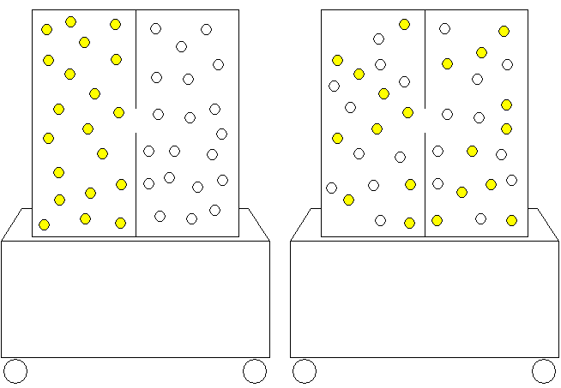
The entropy demonstration is prepared in the same manner as the equilibrium demonstration. The divider containing a hole in the middle is inserted, and the machine is filled with the yellow and white balls on opposite halves. In this demonstration, the ping-pong balls are said to represent molecules. When the blowers are turned on, the balls will mix and distribute themselves evenly among the two sides. The power of this demonstration lies in the question that should be asked after mixing has occurred: “How long do we need to leave the machine running before we will see the ping-pong balls separate into groups of like colors once more?” It can be noted that un-mixing the balls will take a bit of effort and will not occur without some type of outside force interfering and using up energy.

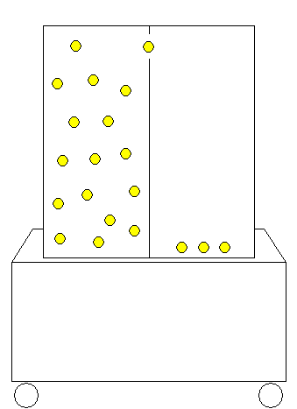
Using the Simulator to Demonstrate Activation Energy

This demonstration works well in conjunction with the next demonstration listed in this booklet. The chamber is set up with the divider containing a hole near the top and one gross on ping-pong balls in the student’s left side of the machine. The blowers are set at low power on each side. The side with the ping-pong balls is said to represent reactants, while the empty side is said to represent products. The power should be low enough so that no ping-pong balls change sides. The hole at the top is representative of the energy barrier that reactant molecules must overcome in order for the reaction to proceed. The students are asked to propose a change to the system that would allow for product creation. Increasing the temperature (or blower power) seems to be the most viable option given the current setup. This is tested and shown to work. Since the power on the product side of the chamber is set low, it will be nearly impossible to lose any product. This provides a good scenario for discussing reversibility.
An alternative to increasing the temperature is to add a catalyst to lower the activation energy. Adding a catalyst can be represented by replacing the divider with the one that contains a hole in the middle. This can provide a good lead-in to the next demonstration.

Using the Simulator to Demonstrate Orientation between Colliding Atoms/Molecules

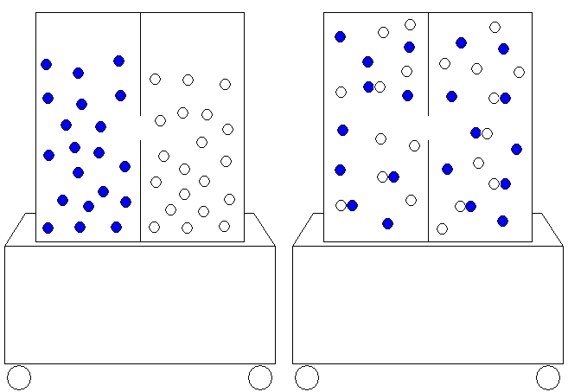
This demonstration is performed with the blue and white balls that contain Velcro. The machine is setup to contain the blue and white balls on opposite sides of the divider that contains a hole in the middle. The two blowers are set to push the blue and white reactant molecules into the gas phase. The hole in the divider represents the activation energy necessary for a reaction to occur.
A reaction is said to be complete when a blue ball becomes attached to a white ball. The power of the blowers should be sufficient to keep a cluster of attached ping-pong balls afloat. The point to be made with this demonstration is that not only do reactant molecules have to collide with enough energy, but they must also collide with the correct orientation. Over time, more and more clusters will form until nearly all balls will appear to be joined by Velcro.

Using the Simulator to Demonstrate Distillation
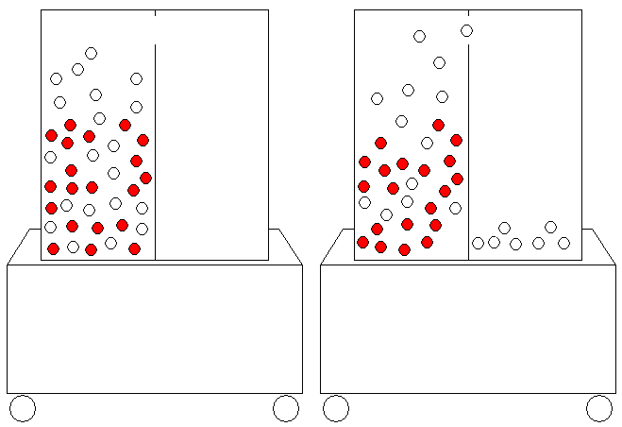
The chamber is set up with mixture of two substances with differing boiling points (white balls and red balls weighted with pennies) on one side of the divider that contains a hole near the top. The hole in the divider is said to represent a condenser. Since distillation requires heating the mixture, the variac should be turn up somewhere above 90 volts. The mixture will begin to evaporate, with a majority of the white balls reaching heights greater than the heights reached by the red balls. Eventually, the white balls will reach the condenser (5 inch hole) one at a time. If left running for a few minutes, the mixture will begin to separate as more and more white balls reach the condenser.

Using the Simulator to Demonstrate Evaporation/Diffusion
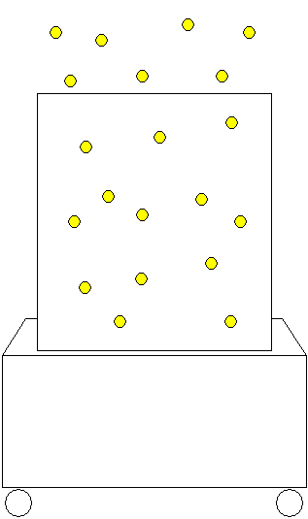

This demonstration is meant to be performed as a last minute gag if a series of demos are to be performed. The chamber is filled with a gross of ping-pong balls and is left without a divider. The variacs should be set to a high voltage (around 90), and the ping-pong balls should be said to represent the molecules near the surface of a liquid. The lid is then removed from the machine and students watch as the molecules “evaporate” into the room. Though this makes a mess in the room, the students will usually help recover the molecules without being asked.

