6-4
The Phosphorus Sun

Description: A small chunk of phosphorus is ignited by flame and quickly plunged into a flask containing oxygen gas. The resulting reaction produces heat, smoke and a spectacular bright light that last for 5-10 seconds.

Concept: Finely dispersed phosphorus will readily ignite in the presence of oxygen at room temperature and must be stored under water or in a solvent such as carbon disulfide. The chunks of phosphorus used in this demonstration have a smaller surface area, and need to be brought to 10-15 degrees above room temperature to ignite. Once a chunk is ignited and plunged into oxygen, the following reaction takes place:

P_{4(s)} + 5O_{2(g)} → P₄O_{10(s)} + heat + light

When the reaction is complete, the P₄O_{10(s)} can be safely disposed of after adding water:

P₄O_{10(s)} + H₂O → H₃PO_{4(aq)}

Materials:
- Small chunk of yellow (or white) phosphorus stored under water
- Forceps
- Oxygen cylinder equipped with tubing
- 5 Liter flask
- Size 11 rubber stopper with hole
- Size 11 rubber stopper without hole
- Deflagrating spoon
- Cork ring
- Propane torch, grill starter or cigarette lighter
- Flint striker (if propane torch is used)
- Slab of some heat-resistant surface

Procedure:
Before Class:
To fill the flask with oxygen, rest the flask on a cork ring and put the end of the tubing attached to the tank into the bottom of the flask. Open the cylinder to allow a gentle stream of oxygen to flow. Purge the flask for about 10 minutes with this slow stream of oxygen. After purging, stopper the flask tightly until the demonstration is to be performed. Prepare this flask no more than an hour or two prior to performing the demonstration. The flask should be set up on a cork ring that is resting on a heat resistant material before attempting the demonstration. The deflagrating spoon should be bent at one end and put through the hole in the size 11 stopper as shown in the diagram shown on the next page.

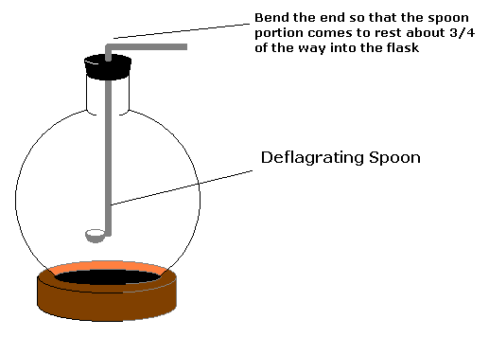

During Class:
Using clean forceps, obtain a small, half pea-sized chunk of phosphorus and place it in the deflagrating spoon (with the holed stopper still attached). Loosen the solid stopper from the oxygen flask and ignite the phosphorus using the flame source of choice. Be sure that the phosphorus and flame source are a safe distance from the oxygen flask when doing this. Once the phosphorus chunk begins to spark, remove the solid stopper from the flask, and drop the deflagrating spoon into the opening. Stand back and enjoy!

Safety:
- When filling the flask with oxygen, make sure there are no sources of heat, sparks or materials present that will readily react with oxygen.
- Wear safety goggles and gloves at all times when working with phosphorus and open flames.
- Some demonstrators prefer to perform the demonstration in a hood or behind a safety shield. If done properly, the reaction should not escape the confines of the flask, but if additional protection is requested, it can be provided.

