16-5
“The Rainbow Connection”

Source: Based on a demonstration by Bill Hutton and Wayne L. Smith, Journal of Chemical Education, February 1984, pages 172-173

Description: A perfect opening demonstration to introduce acid/base indicators to students. Six wine glasses are filled with the same “mystery” liquids. Each glass takes on a different color of the rainbow, despite the fact that the same liquids were added to each. Each glass is treated with a specific mixture of indicators before the demo is performed.

Materials:
- Six wine glasses
- Glass mystery bottle (contains H₂SO₄ / Ethanol mixture)
- Plastic mystery bottle (contains 0.012M NaOH)
- Indicator solutions in dropper bottles (marked by color)
- H₂SO₄ / Glycerol solution
- Large, transparent pitcher

Safety: Gloves and goggles / safety glasses are a must, as strong acid and base will be used.

Procedure:
Before Class:
2-3 drops of the indicator solutions should be put into the bottom of the appropriate wine glasses. This will dry to form a thin film. Approximately 10-20mL of the acid / glycerol solution should be put into the bottom of the large pitcher. There should be enough solution to nearly cover the bottom surface.

During Class:
About 45mL of the acid/ethanol mixture (from the glass “?????” bottle) is added to each glass. This volume can be measures using the marked cup provided. Each glass should still be clear. Add NaOH from the plastic “?????” bottle to each glass until the color is developed in each glass. When all colors have been developed, pour each solution from the wine glasses (I usually do 2 at a time) into the large pitcher. The acid / glycerol solution will lower the pH enough to bring the indicator color back to clear.

Clean-Up: The solution mixture in the pitcher can be poured down the drain.

Background: The indicators used are shown on the next page. In each case, the deprotonation on an OH group causes the color change to arise. The indicators provide the primary colors that are a base for the orange, green and violet.

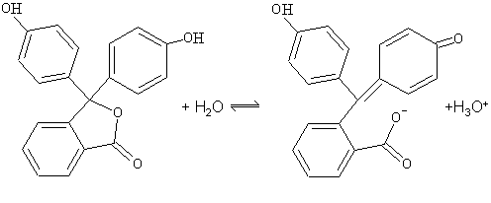
Phenolphthalein
(Pink Color at high pH)

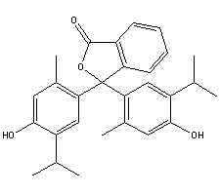
Thymolphthalein
(Blue color at high pH, analogous to Phenolphthalein)

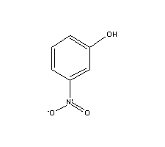
3-nitrophenol
(Yellow color at high pH)

