15-11
The Glowing Pickle

Description: A pickle is placed into a light socket and a tungsten electrode is put through the top. The lights are turned low and current is sent arcing through the pickle from a variac that had been plugged into a wall outlet. The pickle glows brightly for a few seconds and eventually starts to smoke.

Concept: The pickling process involves soaking a cucumber in a concentrated salt solution (or brine). Water flows out of the cucumber and salt flows into the cucumber, creating a salty, dehydrated cucumber (or pickle). The inside of the pickle is essentially an electrolyte solution, and conducts electricity. When a high enough current is supplied to this electrolyte solution, the result is a arcing of sparks through the pickle that appears as a glow when the room lighting is low enough.

Materials:
- Glowing Pickle Apparatus (see diagram)
- Pickle
- Sandpaper
- Variac

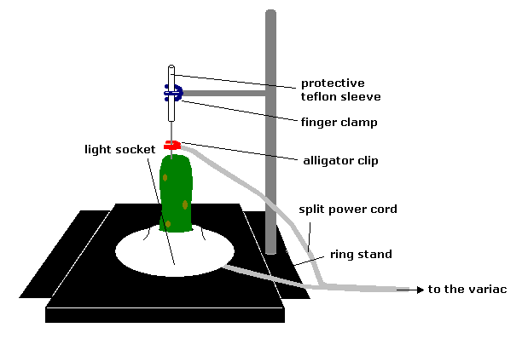
Safety: PLEASE READ THE PROCEDURE THOROUGHLY AND FOLLOW ANY SAFETY INSTRUCTIONS INCLUDED!!!

Procedure:
Do not plug the variac into the wall outlet until just before the demonstration is to be performed. Before inserting the pickle into the socket, polish the metal surface at the bottom of the outlet so that the pickle can make good contact with it. It also may be helpful to slice a small portion of the skin from the bottom of the pickle, so that the metal is in contact with the inside of the pickle. Once the pickle is resting on the metal surface at the bottom of the socket, push the tungsten rod 1-2 inches into the pickle. Some pickles have a hollow channel through the center, so it is best to put the tungsten rod just slightly off-center. Attach the alligator clip from the cord to the tungsten rod. If the rod appears dingy, you may want to sand it as well before supplying any power. The rod should be held in place by a finger clamp that is attached to the Teflon sleeve. Do not clamp the tungsten rod directly to the finger clamp. The Teflon sleeve acts as a heat insulator and also helps ensure that the current will not arc in an undesired direction. Once all connections have been made, plug the cord into the variac, plug the variac into the wall and turn the variac’s power switch the the “on” position (in that order). Dim the lights and increase the voltage provided by the variac. You will hear the pickle begin to sizzle, and at a point near the maximum value on the variac dial, arcing should occur and cause the pickle to glow. When the pickle has ceased to glow, turn the knob all the way down on the variac a shut the power off. Unplug the variac from the wall before unplugging the apparatus from the variac. Be sure not to leave the power connected after the demonstration is over.

