12-21
Using Ninhydrin for Detecting Fingerprints

Description:
A TLC plate containing fingerprint residue is dipped into a solution containing ninhydrin. The plate is heated to reveal the burgundy-colored mark of a distinguishable fingerprint.

Materials:
- TLC plate
- TLC jar containing 0.5% ninhydrin in acetone
- Forceps
- Heat lamp

Concept:
The reaction showing the creation of the burgundy color is shown below:

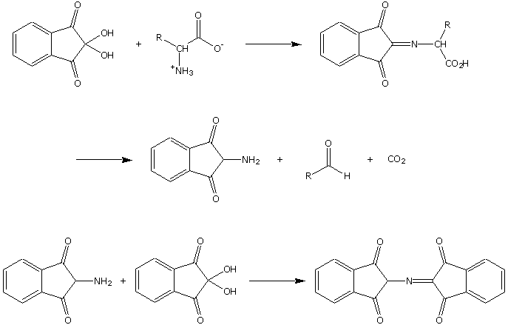

Ninhydrin will react with the amino acids in fingerprint residue to produce the first product shown. Thermal decomposition creates the amine shown, as well as an aldehyde containing the R group from the amino acid and carbon dioxide. The amine reacts with another ninhydrin molecule to produce the burgundy-colored molecule shown above.

Procedure:
The demonstrator may request a volunteer from the class to supply a fingerprint. The source of the fingerprint should wet his/her finger or thumb a little before touching the TLC plate. The plate containing the fingerprint is dipped into the ninhydrin solution using the forceps provided. The plate is set onto a tabletop or shaken in the air to dry. The dried plate is held close to a heat lamp for 30 seconds to 1 minute. The fingerprint will eventually become a burgundy color.

Safety:
Wear gloves and goggle when performing this demo. Ninhydrin is toxic and will irritate the skin.

