2-2
Column Chromatography of Plant Pigments
from Spinach Extract

Description: A deep, yellow-green extract derived from raw spinach is eluted through a chromatography column containing silica. The result is a separation of the β-carotene and chlorophyll pigments in the spinach. When the demo has been completed, the students should be able to see distinct yellow and green bands in the column. If desired, the pigments can be collected as fractions and an absorbance spectrum of the two can be shown to the class.

Concept: Molecules contained within a mixture can be separated based on their differing affinities for various solvents. The β-carotene/chlorophyll mixture can be extracted from spinach using petroleum ether and acetone. The β-carotene has an affinity for petroleum ether, while the chlorophyll has an affinity for acetone. After the mixture has been delivered to a silica-packed column, the addition of petroleum ether can successfully elute the yellow β-carotene. The later addition of acetone can elute the chlorophyll that was unaffected by the addition of petroleum ether.

Materials:
- Large Mortar and Pestle
- Fresh Spinach
- Petroleum Ether
- Acetone
- 125mL Erlenmeyer flask with stopper
- Large, glass chromatography column (from undergraduate labs)
- Stopper to fit column or Parafilm
- Short length of tubing to fit column
- Pinch clamp
- Glass wool
- Sand
- Silica
- 2 plastic weighing boats
- Plastic funnel
- Large, glass stirring rod
- Large crystallizing dish
- Ring stand
- 2 finger clamps
- Green pipet pump
- 3, 5mL Mohr pipets

Procedure:
Preparing the Extract:
Tear 10-15g of spinach leaves into small pieces, and place them in the large mortar. Add about 50mL of an 80:20 volume-to-volume mixture of petroleum ether and acetone to the spinach. Grind the mixture until the solvent takes on a deep, green color. Decant the liquid and retain it in a 125mL Erlenmeyer flask fitted with a stopper. If more extract is desired, continue to add solvent to the mixture along with a few small pieces of spinach before continuing to grind.

Preparing the Column: (see the diagram on the next page)
Mount the column at the top and bottom to a ring stand using two finger clamps. Soak a small amount (~0.1g) of glass wool in petroleum ether and push it to the bottom of the column using a large, glass stirring rod. Making sure that the tube at the bottom of the column is securely clamped shut, add enough petroleum ether to the column (using a funnel) to reach a height of about 15cm. Pouring from a weighing boat, add enough sand to the column to reach a height of 1cm above the glass wool. Tap the side of the column gently with the stir rod to ensure that the sand has settled evenly. Slowly, using a weighing boat, add enough silica to the column to obtain a height of about 10cm. You will need to add this in small portions while tapping the column with the stir rod to ensure even settling. Add another 1cm of sand to the top of the column in a similar manner. There should be enough petroleum ether in the column to reach above the height of this last addition of sand. Open the pinch clamp and drain the excess petroleum ether into the crystallizing dish until the level of the ether is just above the top layer of sand. Stopper the column or use Parafilm to keep the petroleum ether from evaporating before the demo is to be performed.

In Class: (see the diagram on the next page)
Carefully pipet about 5mL of the spinach extract onto the top of the column. With the crystallizing dish resting below the column, open the pinch clamp to allow eluting to begin. A yellow band of β-carotene will begin to move down the column. Using a funnel or Mohr pipet, continue to add petroleum ether carefully to the column until the yellow band has reached the desired distance of travel. Do not let the level of the petroleum ether fall below the top layer of sand at any point. The β-carotene can be eluted through the bottom of the column to be collected, or it can remain in the column so that two distinct bands of color can be later pointed out. To begin the elution of chlorophyll, carefully add about 5mL of acetone to the top of the column. This will produce a green band in the column. This chlorophyll can be collected or retained in the column with the β-carotene. For most purposes, it is sufficient to leave the two pigments in the column so that the students can see that the extract has separated into two components. If requested, transparencies containing the absorbance spectra of the two pigments can be provided.

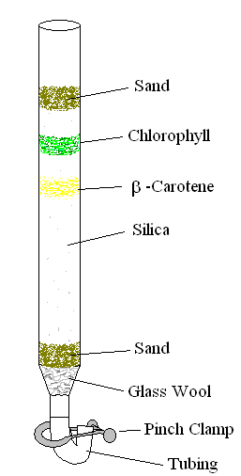

Safety:
Wear gloves and goggles at all times while preparing and performing this demonstration. Do not place the acetone or petroleum ether near any source of heat, sparks or flame.

Clean-Up:
Retain the column and the contents of the evaporating dish for the demonstration technician to dispose of

