2-1
Paper Chromatography

Description: Several types and colors of markers are spotted onto chromatography paper and allowed to develop for 10-15 minutes in a chamber containing water as the mobile phase.

Concept: A mixture of chemicals can be separated based on their relative affinities for the chromatography paper and solvent.

Materials:
- 9” x 5” chromatography paper
- Several permanent, wet-erase and hi-liter markers
- 800 mL beaker
- ruler
- 100mL graduated cylinder
- stapler
- pencil

Procedure:
Using the pencil and ruler, draw a straight line ¾” from the bottom of the chromatography paper. The line should stretch across the longer dimension of the paper. Select no more than 8 markers for use and apply these as 2-3mm spots along the line you had previously drawn (labeling the spots with pencil as you go). The spots should start at least one inch from the left and right edges and be spaced at least one inch from one another. Roll the spotted paper into a cylinder and secure the right and left edges of the paper to one another using staples near the top, middle and bottom. The edges of the paper should not actually touch, but only be bridged together by the staples (see diagram).

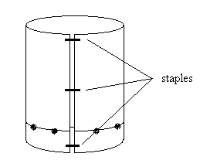
Add 75mL of water to the 800 mL beaker. Insert your prepared chromatography paper into the chamber you have created, holding the spotting line parallel to the surface of the water at all times. After 10-15 minutes, some of the inks will have separated into their component colors. Other inks will travel with the water and not separate, while others will remain on the spotting line.

